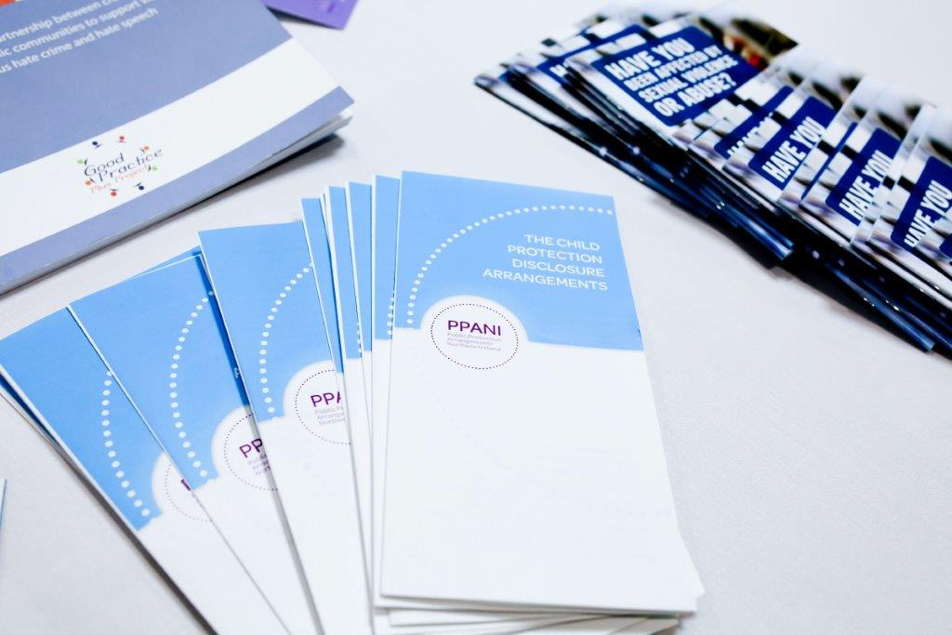

**PPANI ANNUAL REPORT**

**1st April 2022 – 31st March 2023**

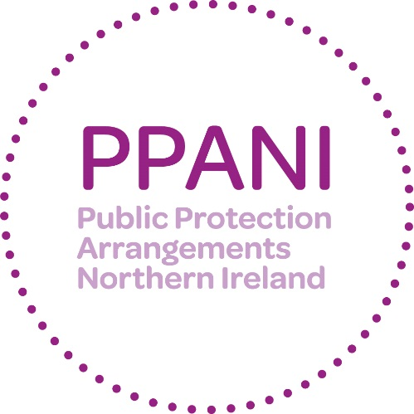

**Forward –**

**Michael McAvoy, Chair of PPANI**

**Strategic Management Board**

This report reflects on the work of agencies involved in delivering the Public Protection Arrangements Northern Ireland (PPANI). The shared aim of PPANI partners is to manage the risk posed by the most serious sexual and violent offenders and to keep the public safe from harm.

The legislative landscape has changed in recent years, with the introduction of coercive control and stalking related offences. Over the last year, the statutory guidance governing PPANI, as well as the operational Manual of Practice, has been amended to make clear that individuals convicted of these offences are eligible for monitoring under the arrangements. As these cases begin to come before the courts, partners will continue to enhance their understanding and supervision of those who commit these crimes. As prevention orders for these offences come into use, partners will review and consider how these can be used effectively to protect victims.

Maintaining best practice on risk assessments is key to effective public protection. Over the reporting period, a new model of risk assessment - the Static 99-R – has been put in place. Training is nearing completion and PPANI agencies are committed to fully implementing this new tool in the coming months.

Ongoing learning and review is a key feature of effective risk management. In the post-Covid environment, it is timely to consider the optimal operational model for delivering public protection. PPANI Senior Management Board has agreed to reviews of the co-located Public Protection Team and on the likely future demand on the arrangements. It is anticipated that the findings will inform and help shape delivery over the next reporting period.

I am also pleased to report that two Lay Advisers have been appointed to oversee PPANI. They are independent and deliver a vital challenge function by acting as a ‘critical friend’ to the agencies. I look forward to their assessments on how the arrangements are operating and any potential enhancements.

I would like to thank all of the PPANI agencies for their ongoing commitment to public protection. This is a dynamic and demanding area of work. It is vital that we continue to work together to meet the challenges of supervising complex offenders and safeguarding vulnerable people in order to protect the public we serve.

**WHAT IS PPANI?**

# PPANI background

The Criminal Justice Order (NI) 2008 created the public protection arrangements. The arrangements bring together a number of agencies and departments including the police, probation, prison service, health trusts and a number of other agencies to work together to provide effective assessment and management of the risks posed by certain sexual and violent offenders.

**List of Agencies & Departments statutorily obliged to cooperate under PPANI**

* Police Service of Northern Ireland
* Probation Board for Northern Ireland
* Northern Ireland Prison Service
* Health & Social Care Trusts
* Northern Ireland Housing Executive
* Department of Education
* Department for the Economy
* Department of Health
* Department for Communities
* Education and Library Boards
* Youth Justice Agency
* National Society for the Prevention of Cruelty to Children (NSPCC)
* The Strategic Planning & Performance Group

The arrangements in Northern Ireland also have two Lay Advisors; they are full members of the Strategic Management Board and their role is to provide a challenge to the professionals and act as a “critical friend” (these posts are currently vacant, although a recruitment campaign is being progressed). The Department of Justice has policy responsibility for the risk assessment and management arrangements set out in the Criminal Justice (NI) Order 2008. The DoJ also acts to ensure that the funding provided is allocated to effectively deliver oversight of arrangements; and to ensure that all appropriate information regarding the public protection arrangements is provided to the Minister.

# How PPANI works

The agencies listed above work together, within the Public Protection Arrangements, to decide how best to minimise the likelihood of offenders further causing serious harm to the public.

Offenders including those convicted of certain Sexual Offences, Violent Offences, Hate Crimes and Domestic Violence are identified and information about those offence types is gathered and shared across relevant agencies. The nature and level of the risk of harm they pose is assessed and, where necessary, a risk management plan is implemented to protect the public. In most cases, the offender will be managed under the single agency statutory responsibilities of the relevant responsible agencies. However, a number of offenders will require multi-agency assessment and their risk management plans will be developed and actioned via multi agency Local Area Public Protection Panels (LAPPPs). These panels are made up of representatives from the agencies that have a statutory responsibility or operational interest in the cases which are subject to assessment and management of risk. LAPPPs meet in various locations throughout Northern Ireland. For a full explanation on the operations of PPANI visit our website <http://www.publicprotectionni.com/index.php/operation>

# Risk Assessment

Information relating to risk is presented to the Local Area Public Protection Panel (LAPPP) for assessment. The LAPPP is chaired by a Probation Board Area Manager and made up of Police Officers, Probation Officers, Social Workers, Prison Staff and other professionals.

This assessment process results in the offender being confirmed in one of three categories of risk:

### Category 1

Someone whose previous offending and/or current behaviour and/or current circumstances present little evidence that they could cause serious harm through carrying out a sexual or violent offence.

### Category 2

Someone whose previous offending and/or current behaviour and/or current circumstances present clear and identifiable evidence that they could cause serious harm through carrying out a sexual or violent offence.

### Category 3

Someone whose previous offending and/or current behaviour and/or current circumstances present clear and identifiable evidence that they are highly likely to cause serious harm through carrying out a sexual or violent offence.

# Information that can be shared about Offenders

The Public Protection Arrangements aim to ensure that relevant information is available in good time to help those making risk assessments and drawing up risk management plans. The agencies involved recognise that the sharing of information between agencies is critical and each has signed up to an information sharing agreement. The current law on data protection prevents complete disclosure of information on offenders to the public. Information can, however, be disclosed to members of the public in certain circumstances where this is deemed necessary for protecting the public and can be justified by the evidence of risk.

# Risk Management

For cases where the risk level is assessed as Category 1, these are managed by a single agency in the community.

Multi-agency risk management plans are developed where the risk is assessed as Category 2 and Category 3. For each of the categories, a Designated Risk Manager (DRM) will be appointed. The DRM will be given specific responsibility for coordinating the risk management plan and ensuring that the actions contained in it are carried out. Risk management plans are specifically tailored to each offender and set out all the actions which the agencies will take, or require the offender to take, to minimise the risks he or she poses. Risk management plans will normally include both enforcement actions to restrict the offender’s behaviour and positive encouragement actions designed to help him or her avoid causing serious harm through reoffending.

Each risk management plan will include home visits from the DRM, and other professionals including police to make sure the offender is complying with the plan.

Visits will be both announced and unannounced. Risk management plans for Category 2 and 3 are subject to reviews by the Local Area Public Protection Panels no later than every 16 weeks.

# Ensuring a Victims Perspective

The importance of protecting victims of crime and properly addressing their needs is fully recognised and supported by those agencies operating within the arrangements. When planning for the management of offenders in the community, the protection of victims remains of paramount importance. Victims of offenders whose risks are being managed by agencies within the public protection arrangements are provided with an information pack relevant to their own particular circumstances. They will also be provided with the name and telephone number of a police officer who will act as a point of contact on the Public Protection Arrangements.

There are also a number of schemes/organisations that can provide assistance and information. In 2012 the Prisoner Release Victim Information Scheme, the Probation Board for Northern Ireland Victim Information Scheme and the Mentally Disordered Victim Information Scheme were brought together to help streamline services to victims and are managed under the PBNI Victim Information Unit. These schemes are voluntary and it is necessary to register with them. Information can be obtained regarding the PBNI Victim Information Scheme via [victiminfo@pbni.gsi.gov.uk](mailto:victim@pbni.gsi.gov.uk). Information regarding the Prisoner Release Victim Information Scheme can be obtained via [NIPRVIS@dojni.x.gov.uk](mailto:NIPRVIS@dojni.x.gov.uk).

At an operational level victims’ issues are also central. At each Local Area Public Protection Panel (LAPPP) meeting, victims’ issues are standing agenda items.

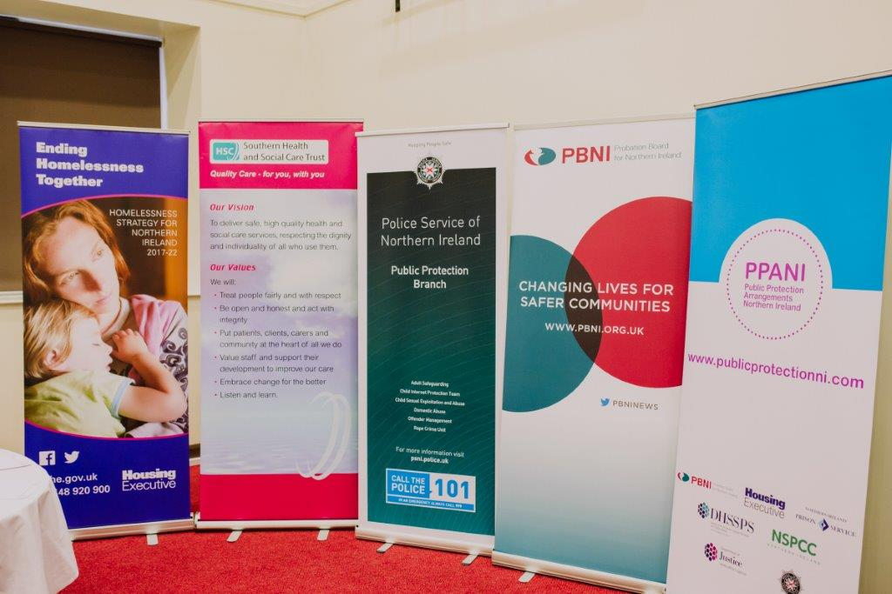

**Strategic Management Board**

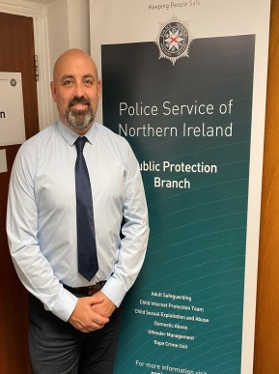

Michael McAvoy D/Chief Supt Anthony McNally

Department of Justice Police Service of Northern Ireland



Alan Smyth Bronagh Muldoon

Northern Ireland Prison Service NSPCC in Northern Ireland



Stephen Hamilton Richard Tanswell

Probation Board for Northern Ireland Northern Ireland Housing Executive



Colum McCafferty

Southern Health and Social Care Trust

**Key Achievements 2022-23**

Over the past year, the PPANI agencies have continued to work together and share information to inform and provide robust risk management plans for PPANI eligible offenders (sexual and certain violent offenders). There have been a number of developments in the past 12 months, which have enhanced the effectiveness of the arrangements and helped the agencies work better to protect the public:

* Prior to the introduction of new Domestic Abuse legislation in February 2022, ensured that practitioner’s from all PPANI agencies received appropriate training in respect of ‘Coercive Controlling Behaviour’ and new preventative orders e.g. Domestic Abuse Prevention Orders (DAPOs).
* In light of new Domestic Abuse legislation, along with the Department of Justice reviewed the Minister of justice’s Guidance to PPANI agencies (Article 50) to ensure that it remains fit for purpose.
* Continue to review the PPANI Manual of Practice to reflect changes in legislation and learning from PPANI Serious Case Reviews.
* Development of implementation plan re introduction of new static model of risk assessment within PPANI, i.e. Static 99-R.
* Continued to build upon relationships with colleagues in other jurisdictions re training and partnership working, e.g. Static 99-R Risk Assessment ‘train the trainer’ event held in partnership with Criminal Justice Scotland.
* Following a pilot developed a hybrid approach to multi-agency working in the post COVID environment e.g. holding Local Area Public Protection Panel meetings via both virtual platforms and ‘face to face’.

**Our Objectives for the next 12 Months**

The Strategic Management Board have a number of key objectives for the coming 12 months. These include:

* In light of forthcoming new legislation in respect of Stalking/Harassment, ensure that practitioners from all PPANI agencies receive appropriate training in respect of preventative orders e.g. Stalking Protection Orders.
* Delivery of training re accredited static risk assessment tool; Static 99-R to practitioners from all PPANI agencies.
* Implement the findings/recommendations arising from the review of the Minister of justice’s Guidance to PPANI agencies (Article 50)
* Following Ensuring the implementation of recommendations arising from current Serious Case Reviews.
* Continued engagement with the Home Office and colleagues from Public Protection Agencies in England/Wales and Scotland re development of a common multi-agency Information System f i.e. Multi-Agency Public Protection System (MAPPS)
* Promote the usage of preventive orders e.g. Violent Offences Prevention Orders (VOPOs) across all PPANI agencies.
* Ongoing engagement with community groups, the media and elected

representatives.

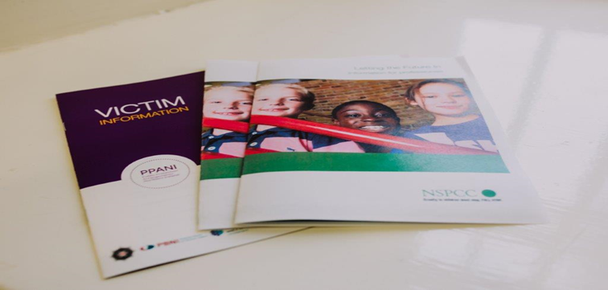

**PPANI Statistics**

|  |  |
| --- | --- |
| **Number of Cat 2 offenders at 31st March 2023** | **508** |
| **Number of Cat 3 offenders at 31st March 2023** | **22** |
| **Total Cat 2 and 3 Offenders at 31st March 2023** | **530** |

|  |  |
| --- | --- |
| **LAPPP data 1st April 2022 -  31st March 2023** | |
| **Total number of LAPPP Reviews** | **1092 cases heard** |
| **Number reviewed in community** | **845 cases heard** |
| **Number reviewed in custody** | **247 cases heard** |
| **Number of Initial Referrals** | **492 NCS cases heard** |
| **Number of Review Referrals** | **600 review cases heard** |
| **Number of Cases re-categorised to Cat 1** | **181 cases set at CAT 1** |

|  |  |
| --- | --- |
| **DRM by Agency At 31st March 2023 (CAT 2/3/NCS/P)** | |
| **PBNI** | **533** |
| **PSNI** | **384** |
| **NIPS** | **165** |
| **Trusts** | **8** |

**Explanatory commentary on statistical tables**

a) The totals of PPANI eligible offenders, broken down by category, reflect the picture on 31st March 2023 (i.e. they are a snapshot).

b) Sex offenders – those who are required by law to notify the police of their name, address and other personal details and to notify any changes subsequently (known as ‘notification requirements’ or ‘the sex offender register’). Failure to comply with the notification requirements is a criminal offence which carries a maximum penalty of 5 years imprisonment.

c) Violent offenders – those who have been convicted of a violent offence against a child or vulnerable adult, or violent offences within a domestic situation, as well as other violent offences which have been aggravated by hostility.

d) Public Protection Team (PPT) - This is a small team of highly experienced police, probation and social services staff whose aim is to provide a consistent level of management of risk for those offenders in the community who represent the greatest cause for concern.