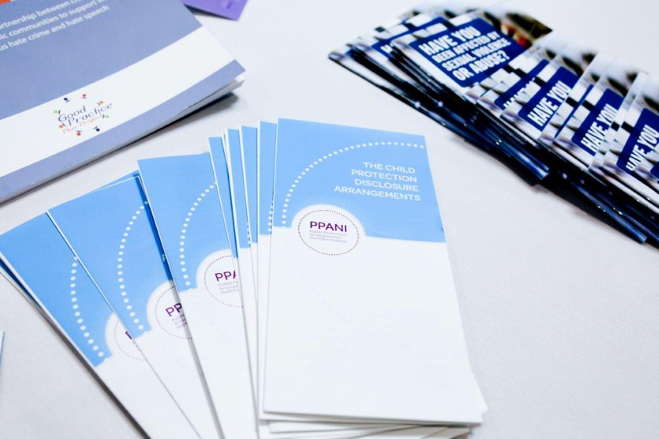

PPANI ANNUAL REPORT
1st April 2021 – 31st March 2022

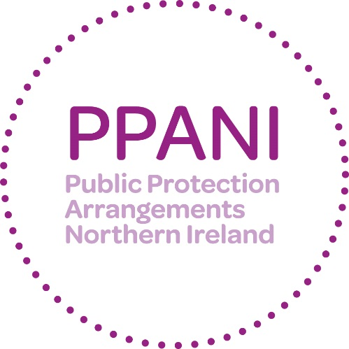

Forward –
DCS Anthony McNally,
Chair of PPANI
Strategic Management Board

This has been a momentous year for legislative changes in Northern Ireland that strengthen our collective response to violent offences such as Domestic Abuse and Stalking. The agencies who work together to deliver the Public Protection Arrangements in Northern Ireland (PPANI) have worked hard to make training and operational implementation a top priority, whilst continuing to manage the risk posed by sexual and violent offenders, including those who offend in a domestic setting, against children or vulnerable adults.
This report reflects on the contributions made by all over the last twelve months, demonstrating the accountability to the public and providing reassurance that, under the governance of the Strategic Management Board (SMB), the arrangements continued to provide an effective framework.
Our Special Interest Seminar this year focused on the enactment of the new Domestic Abuse legislation which went live in February. The new legislation criminalises coercive and controlling behaviour and introduced two child aggravators.
We invited stakeholders and relevant agencies from across Northern Ireland to hear from criminal justice experts and victim support organisations. As part of this, we heard from one of the Independent Domestic Homicide Review (DHR) Chairs. All PPANI agencies work closely and collaboratively with colleagues in the Department of Justice through the DHR framework as a means to continually learn and do all we can to minimise the number of people who suffer Domestic Abuse and ultimately help prevent future homicides.
In response to the new Domestic Abuse legislation, the Police Service of Northern Ireland, in March 2022, arrested 45 people for this domestic abuse offence, including coercive control. 90% of these crimes were against women and girls.
Following tragic events over last year there has been a national direction to tackle the societal issue of violence against women and girls. The Police Service have created their first ‘Tackling Violence against Women and Girls Action Plan’ for Northern Ireland. This will include a combined operational focus from across all agencies within PPANI and beyond, to address these important matters through safeguarding and the pursuit/management of perpetrators.
Looking forward, there will be a further significant drive from all PPANI agencies to ensure that practitioners receive appropriate training in respect of further new legislation, criminalising stalking and harassment for the first time in Northern Ireland, and any preventative orders that are introduced to aid in the management of these types of complex perpetrators.
The Article 50 guidance that underpins our arrangements was reviewed by the Minister of Justice in relation to the domestic abuse legislation and we will continue to ensure that it remains fit for purpose. The combined impact of all legislative changes over the year has been the biggest change to processes that criminal justice agencies in Northern Ireland have ever seen.
It is clear that we all remain committed to these changes having a positive impact on the lives of those who may be affected and that we will continue to work in partnership to safeguard our most vulnerable and manage the risk that offenders may pose to the wider communities of Northern Ireland.
In closing, I would like to acknowledge the important role that all agencies contributing to the arrangements make to Public Protection. I would like to thank our staff from across all the PPANI partner agencies for their ongoing commitment and dedication to this particularly challenging and complex area of work.
Moving forward I will be stepping down in my capacity as Chair of PPANI Senior Management Board, remaining on the board to represent the Police Service of Northern Ireland. The Department of Justice have appointed their Head of Community Safety Division, Katie Taylor, to take over as Chair and lead on the arrangements for Northern Ireland and I look forward to supporting her in this role.

Detective Chief Superintendent
Anthony McNally

WHAT IS PPANI?

PPANI background

The Criminal Justice Order (NI) 2008 created the public protection arrangements. The arrangements bring together a number of agencies and departments including the police, probation, prison service, health trusts and a number of other agencies to work together to provide effective assessment and management of the risks posed by certain sexual and violent offenders.

List of Agencies and Departments statutorily obliged to cooperate under PPANI
- Police Service of Northern Ireland
- Probation Board for Northern Ireland
- Northern Ireland Prison Service
- HSS Boards and HSS Trusts (Social Services)
- Northern Ireland Housing Executive
- Department of Education
- Department for the Economy
- Department of Health
- Department for Communities
- Education and Library Boards
- Youth Justice Agency
- National Society for the Prevention of Cruelty to Children (NSPCC)
- Health & Social Care Board
- Health Trusts
The arrangements in Northern Ireland also have two Lay Advisors; they are full members of the Strategic Management Board and their role is to provide a challenge to the professionals and act as a “critical friend” (these posts are currently vacant, although a recruitment campaign is being progressed). The Department of Justice has policy responsibility for the risk assessment and management arrangements set out in the Criminal Justice (NI) Order 2008. The DoJ also acts to ensure that the funding provided is allocated to effectively deliver oversight of arrangements; and to ensure that all appropriate information regarding the public protection arrangements is provided to the Minister.

How PPANI works

The agencies listed above work together, within the Public Protection Arrangements, to decide how best to minimise the likelihood of offenders further causing serious harm to the public.
Offenders including those convicted of certain Sexual Offences, Violent Offences, Hate Crimes and Domestic Violence are identified and information about those offence types is gathered and shared across relevant agencies. The nature and level of the risk of harm they pose is assessed and, where necessary, a risk management plan is implemented to protect the public. In most cases, the offender will be managed under the single agency statutory responsibilities of the relevant responsible agencies. However, a number of offenders will require multi-agency assessment and their risk management plans will be developed and actioned via multi agency Local Area Public Protection Panels (LAPPPs). These panels are made up of representatives from the agencies that have a statutory responsibility or operational interest in the cases which are subject to assessment and management of risk. LAPPPs meet in various locations throughout Northern Ireland. For a full explanation on the operations of PPANI visit our website http://www.publicprotectionni.com/index.php/operation

Risk Assessment

Information relating to risk is presented to the Local Area Public Protection Panel (LAPPP) for assessment. The LAPPP is chaired by a Probation Board Area Manager and made up of Police Officers, Probation Officers, Social Workers, Prison Staff and other professionals.
This assessment process results in the offender being confirmed in one of three categories of risk:

Category 1
Someone whose previous offending and/or current behaviour and/or current circumstances present little evidence that they could cause serious harm through carrying out a contact sexual or violent offence.

Category 2
Someone whose previous offending and/or current behaviour and/or current circumstances present clear and identifiable evidence that they could cause serious harm through carrying out a contact sexual or violent offence.

Category 3
Someone whose previous offending and/or current behaviour and/or current circumstances present clear and identifiable evidence that they are highly likely to cause serious harm through carrying out a contact sexual or violent offence.

Information that can be shared about Offenders

The Public Protection Arrangements aim to ensure that relevant information is available in good time to help those making risk assessments and drawing up risk management plans. The agencies involved recognise that the sharing of information between agencies is critical and each has signed up to an information sharing agreement. The current law on data protection prevents complete disclosure of information on offenders to the public. Information can, however, be disclosed to members of the public in certain circumstances where this is deemed necessary for protecting the public and can be justified by the evidence of risk.

Risk Management

For cases where the risk level is assessed as Category 1, these are managed by a single agency in the community.
Multi-agency risk management plans are developed where the risk is assessed as Category 2 and Category 3. For each of the categories, a Designated Risk Manager (DRM) will be appointed. The DRM will be given specific responsibility for coordinating the risk management plan and ensuring that the actions contained in it are carried out. Risk management plans are specifically tailored to each offender and set out all the actions which the agencies will take, or require the offender to take, to minimise the risks he or she poses. Risk management plans will normally include both enforcement actions to restrict the offender’s behaviour and positive encouragement actions designed to help him or her avoid causing serious harm through reoffending.
Each risk management plan will include home visits from the DRM, and other professionals including police to make sure the offender is complying with the plan.
Visits will be both announced and unannounced. Risk management plans for Category 2 and 3 are subject to reviews by the Local Area Public Protection Panels no later than every 16 weeks.

Ensuring a Victims Perspective

The importance of protecting victims of crime and properly addressing their needs is fully recognised and supported by those agencies operating within the arrangements. When planning for the management of offenders in the community, the protection of victims remains of paramount importance. Victims of offenders whose risks are being managed by agencies within the public protection arrangements are provided with an information pack relevant to their own particular circumstances. They will also be provided with the name and telephone number of a police officer who will act as a point of contact on the Public Protection Arrangements.
There are also a number of schemes/organisations that can provide assistance and information. In 2012 the Prisoner Release Victim Information Scheme, the Probation Board for Northern Ireland Victim Information Scheme and the Mentally Disordered Victim Information Scheme were brought together to help streamline services to victims and are managed under the PBNI Victim Information Unit. These schemes are voluntary and it is necessary to register with them. Information can be obtained regarding the PBNI Victim Information Scheme via victiminfo@pbni.gsi.gov.uk. Information regarding the Prisoner Release Victim Information Scheme can be obtained via NIPRVIS@dojni.x.gov.uk.
At an operational level victims’ issues are also central. At each Local Area Public Protection Panel (LAPPP) meeting, victims’ issues are standing agenda items.

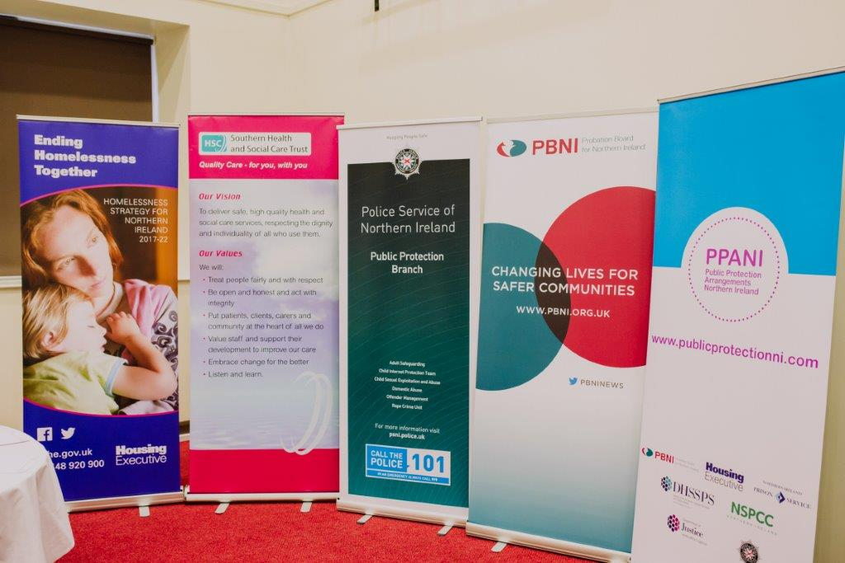

Strategic Management Board

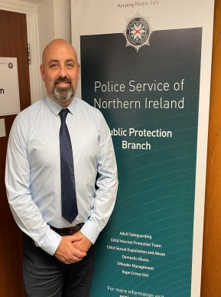
Superintendent Anthony McNally Alan Smyth
PSNI NIPS
Gillian Montgomery Bronagh Muldoon
Probation Board Northern Ireland NSPCC in Northern Ireland

Richard Tanswell Colum McCafferty
Northern Ireland Housing Executive Southern Health and Social Care Trust

Steven Allison
Department of Justice

Key Achievements 2021-22

Over the past year, the PPANI agencies have continued to work together and share information to inform and provide robust risk management plans for PPANI eligible offenders (sexual and certain violent offenders). There have been a number of developments in the past 12 months, which have enhanced the effectiveness of the arrangements and helped the agencies work better to protect the public:

- Prior to the introduction of new Domestic Abuse legislation in February 2022, ensured that practitioner’s from all PPANI agencies received appropriate training in respect of ‘Coercive Controlling Behaviour’ and new preventative orders e.g. Domestic Abuse Prevention Orders (DAPOs).
- In light of new Domestic Abuse legislation, along with the Department of Justice reviewed the Minister of justice’s Guidance to PPANI agencies (Article 50) to ensure that it remains fit for purpose.
- Continue to review the PPANI Manual of Practice to reflect changes in legislation and learning from PPANI Serious Case Reviews.
- Development of implementation plan re introduction of new static model of risk assessment within PPANI, i.e. Static 99-R.
- Continued to build upon relationships with colleagues in other jurisdictions re training and partnership working, e.g. Static 99-R Risk Assessment ‘train the trainer’ event held in partnership with Criminal Justice Scotland.
- Following a pilot developed a hybrid approach to multi-agency working in the post COVID environment e.g. holding Local Area Public Protection Panel meetings via both virtual platforms and ‘face to face’.

Our Objectives for the next 12 Months

The Strategic Management Board have a number of key objectives for the coming 12 months. These include:

- In light of forthcoming new legislation in respect of Stalking/Harassment, ensure that practitioners from all PPANI agencies receive appropriate training in respect of preventative orders e.g. Stalking Protection Orders.

- Delivery of training re accredited static risk assessment tool; Static 99-R to practitioners from all PPANI agencies.

- Implement the findings/recommendations arising from the review of the Minister of justice’s Guidance to PPANI agencies (Article 50)

- Following Ensuring the implementation of recommendations arising from current Serious Case Reviews.

- Development of a pilot re usage of a common multi-agency Information System within the Public Protection Arrangements Northern Ireland

- Promote the usage of preventive orders e.g. Violent Offences Prevention Orders (VOPOs) across all PPANI agencies.
- Ongoing engagement with community groups, the media and elected
representatives.

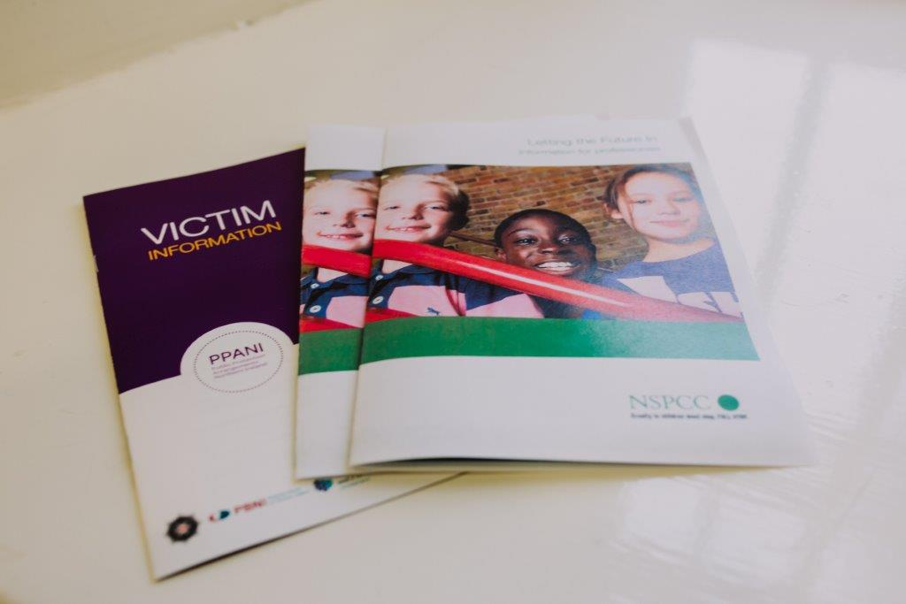

PPANI Statistics

Number of Cat 2 offenders at 31st March 2022 | 454
Number of Cat 3 offenders at 31st March 2022 | 32
Total Cat 2 and 3 Offenders at 31st March 2022 | 486

LAPPP data 1st April 2021 - 31st March 2022

Total number of LAPPP Reviews | 851 cases heard
Number reviewed in community | 656 cases heard
Number reviewed in custody | 195 cases heard
Number of Initial Referrals | 324 NCS cases heard
Number of Review Referrals | 517 review cases heard
Number of Cases re-categorised to Cat 1 | 105 cases set at CAT 1

DRM by Agency At 31st March 2022
(CAT 2/3/NCS/P)
PBNI | 415
PSNI | 326
NIPS | 105
Trusts | 5

Explanatory commentary on statistical tables

a) The totals of PPANI eligible offenders, broken down by category, reflect the picture on 31st March 2022 (i.e. they are a snapshot).
b) Sex offenders – those who are required by law to notify the police of their name, address and other personal details and to notify any changes subsequently (known as ‘notification requirements’ or ‘the sex offender register’). Failure to comply with the notification requirements is a criminal offence which carries a maximum penalty of 5 years imprisonment.
c) Violent offenders – those who have been convicted of a violent offence against a child or vulnerable adult, or violent offences within a domestic situation, as well as other violent offences which have been aggravated by hostility.
d) Public Protection Team (PPT) - This is a small team of highly experienced police, probation and social services staff whose aim is to provide a consistent level of management of risk for those offenders in the community who represent the greatest cause for concern.

