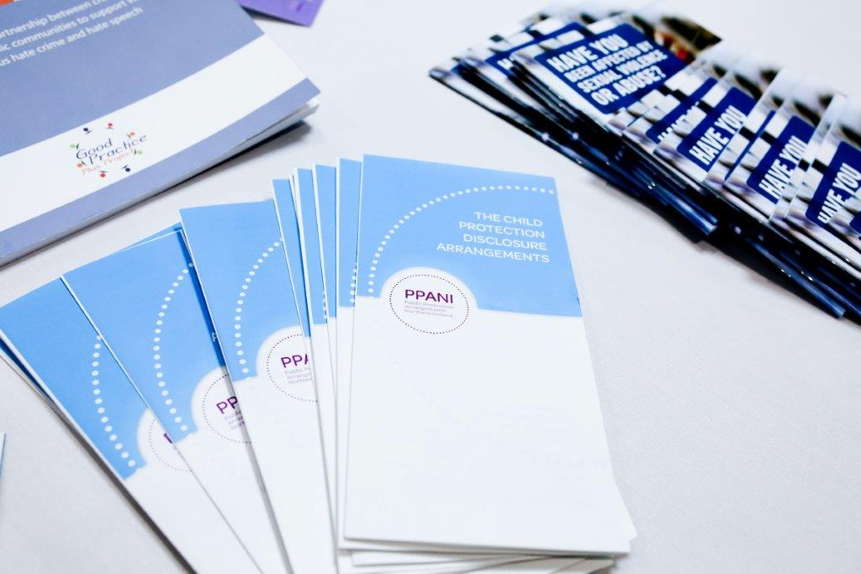

**PPANI ANNUAL REPORT**

**1st April 2019 – 31st March 2020**

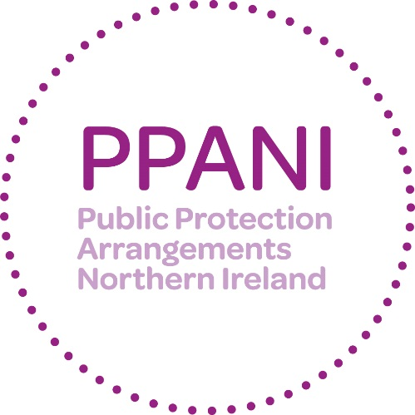

**Forward –**

**DCS Anthony McNally,**

**Chair of PPANI**

**Strategic Management Board**

I am pleased to introduce the 2019/2020 Annual Report on the Public Protection Arrangements in Northern Ireland (PPANI).

The purpose of this report is to demonstrate the accountability of PPANI to the public and to provide reassurance that, under the governance of the Strategic Management Board, the arrangements continue to provide an effective framework for managing the risks to the public posed by sexual and certain violent offenders. This report reflects the contributions made by all the agencies involved in PPANI during the last business year and looks back on developments over that period.

During the period covered by the Annual Report, PPANI SMB was chaired by my colleague D/Chief Superintendent Paula Hilman; who retired from PSNI in April 2020. I would like to thank for Paula for her commitment to the PPANI SMB during her tenure.

I would also like to acknowledge the contribution made to the work of PPANI by Mr Joe Blake, PPANI Lay Advisor. The 2008 Criminal Justice Order required the Department of Justice to appoint two Lay Advisors to the SMB. Lay Advisors are appointed to assist in the review and reporting functions and should act as informed observers and provide a challenge function to the professionals when monitoring the overall effectiveness of the Public Protection Arrangements. Mr Blake completed two three year terms as Lay Advisor and his input at SMB, Sub Groups and Audits was valuable.

Multi-agency working improves information sharing, joint decision making and coordinated intervention. Over the last year there have been a number of developments that have enhanced these elements of our work.

One of the most important aspects of this work is to provide information and raise awareness of public protection issues to the public in order that they can protect and keep safe young people and the most vulnerable in society. The PPANI Coordinator and staff from the agencies have continued to deliver awareness raising presentations and provide information to a range of community/voluntary sector groups (including church & faith groups) and elected representatives.

To coincide with the National Organisation for the Treatment of Abuse (NOTA) holding their Annual International Conference in Belfast from 19th – 20th September 2019, PPANI held a Special Interest Seminar for practitioners entitled ‘Reframing Sexual Abuse facilitated by Professor Kieran McCartan. Practitioners from PPANI agencies were involved in the delivery of workshops at the NOTA conference focusing upon the work of the Co-located PBNI, PSNI & HSCT Public Protection Team and the challenges in securing appropriate accommodation for those individuals managed within the arrangements. Along with colleagues from the Republic of Ireland and the United States of America, the Chair of SMB and PPANI Coordinator contributed to a NOTA Community Engagement event focusing upon ‘Understanding and Responding to Sexual Abuse’. The Chair of SMB also contributed to a policing panel discussion at the conference regarding the potential challenges to public protection arising from EU-Exit.

The end of this reporting period coincided with the onset of the COVID19 pandemic, which has necessitated PPANI agencies to revise operational practices, whilst ensuring that service continuity is maintained. Responding to the COVID19 pandemic and developing recovery models will be challenges for PPANI agencies during 2020/2021.

As the incoming Chair of PPANI SMB, I would like to acknowledge the important role that all agencies contributing to the arrangements make to Public Protection and would like to thank our staff from across all the PPANI partner agencies for their commitment and dedication to this particularly challenging and complex area of work. I look forward to working with partner agencies in my capacity as Chair of PPANI SMB.

Anthony McNally

**WHAT IS PPANI?**

# PPANI background

The Criminal Justice Order (NI) 2008 created the public protection arrangements. The arrangements bring together a number of agencies and departments including the police, probation, prison service, health trusts and a number of other agencies to work together to provide effective assessment and management of the risks posed by certain sexual and violent offenders.

# List of Agencies and Departments statutorily obliged to cooperate under PPANI

* Police Service of Northern Ireland
* Probation Board for Northern Ireland
* Northern Ireland Prison Service
* HSS Boards and HSS Trusts (Social Services)
* Northern Ireland Housing Executive
* Department of Education
* Department for the Economy
* Department of Health
* Department for Communities
* Education and Library Boards
* Youth Justice Agency
* National Society for the Prevention of Cruelty to Children (NSPCC)
* Health & Social Care Board
* Health Trusts

The arrangements in Northern Ireland also have two Lay Advisors; they are full members of the Strategic Management Board and their role is to provide a challenge to the professionals and act as a “critical friend”. The Department of Justice has policy responsibility for the risk assessment and management arrangements set out in the Criminal Justice (NI) Order 2008. The DoJ also acts to ensure that the funding provided is allocated to effectively deliver oversight of arrangements; and to ensure that all appropriate information regarding the public protection arrangements is provided to the Minister.

# How PPANI works

The agencies listed above work together, within the Public Protection Arrangements, to decide how best to minimise the likelihood of offenders further causing serious harm to the public.

Offenders including those convicted of certain Sexual Offences, Violent Offences, Hate Crimes and Domestic Violence are identified and information about those offence types is gathered and shared across relevant agencies. The nature and level of the risk of harm they pose is assessed and, where necessary, a risk management plan is implemented to protect the public. In most cases, the offender will be managed under the single agency statutory responsibilities of the relevant responsible agencies. However, a number of offenders will require multi-agency assessment and their risk management plans will be developed and actioned via multi agency Local Area Public Protection Panels (LAPPPs). These panels are made up of representatives from the agencies that have a statutory responsibility or operational interest in the cases which are subject to assessment and management of risk. LAPPPs meet in various locations throughout Northern Ireland. For a full explanation on the operations of PPANI visit our website <http://www.publicprotectionni.com/index.php/operation>

# Risk Assessment

Information relating to risk is presented to the Local Area Public Protection Panel (LAPPP) for assessment. The LAPPP is chaired by a Probation Board Area Manager and made up of Police Officers, Probation Officers, Social Workers, Prison Staff and other professionals.

This assessment process results in the offender being confirmed in one of three categories of risk:

### Category 1

Someone whose previous offending and/or current behaviour and/or current circumstances present little evidence that they could cause serious harm through carrying out a contact sexual or violent offence.

### Category 2

Someone whose previous offending and/or current behaviour and/or current circumstances present clear and identifiable evidence that they could cause serious harm through carrying out a contact sexual or violent offence.

### Category 3

Someone whose previous offending and/or current behaviour and/or current circumstances present clear and identifiable evidence that they are highly likely to cause serious harm through carrying out a contact sexual or violent offence.

# Information that can be shared about Offenders

The Public Protection Arrangements aim to ensure that relevant information is available in good time to help those making risk assessments and drawing up risk management plans. The agencies involved recognise that the sharing of information between agencies is critical and each has signed up to an information sharing agreement. The current law on data protection prevents complete disclosure of information on offenders to the public. Information can, however, be disclosed to members of the public in certain circumstances where this is deemed necessary for protecting the public and can be justified by the evidence of risk.

# Risk Management

For cases where the risk level is assessed as Category 1, these are managed by a single agency in the community.

Multi-agency risk management plans are developed where the risk is assessed as Category 2 and Category 3. For each of the categories, a Designated Risk Manager (DRM) will be appointed. The DRM will be given specific responsibility for coordinating the risk management plan and ensuring that the actions contained in it are carried out. Risk management plans are specifically tailored to each offender and set out all the actions which the agencies will take, or require the offender to take, to minimise the risks he or she poses. Risk management plans will normally include both enforcement actions to restrict the offender’s behaviour and positive encouragement actions designed to help him or her avoid causing serious harm through reoffending.

Each risk management plan will include home visits from the DRM, and other professionals including police to make sure the offender is complying with the plan.

Visits will be both announced and unannounced. Risk management plans for Category 2 and 3 are subject to reviews by the Local Area Public Protection Panels no later than every 16 weeks.

# Ensuring a Victims Perspective

The importance of protecting victims of crime and properly addressing their needs is fully recognised and supported by those agencies operating within the arrangements. When planning for the management of offenders in the community, the protection of victims remains of paramount importance. Victims of offenders whose risks are being managed by agencies within the public protection arrangements are provided with an information pack relevant to their own particular circumstances. They will also be provided with the name and telephone number of a police officer who will act as a point of contact on the Public Protection Arrangements.

There are also a number of schemes/organisations that can provide assistance and information. In 2012 the Prisoner Release Victim Information Scheme, the Probation Board for Northern Ireland Victim Information Scheme and the Mentally Disordered Victim Information Scheme were brought together to help streamline services to victims and are managed under the PBNI Victim Information Unit. These schemes are voluntary and it is necessary to register with them. Information can be obtained regarding the PBNI Victim Information Scheme via [victiminfo@pbni.gsi.gov.uk](mailto:victim@pbni.gsi.gov.uk). Information regarding the Prisoner Release Victim Information Scheme can be obtained via [NIPRVIS@dojni.x.gov.uk](mailto:NIPRVIS@dojni.x.gov.uk).

At an operational level victims’ issues are also central. At each Local Area Public Protection Panel (LAPPP) meeting, victims’ issues are standing agenda items.

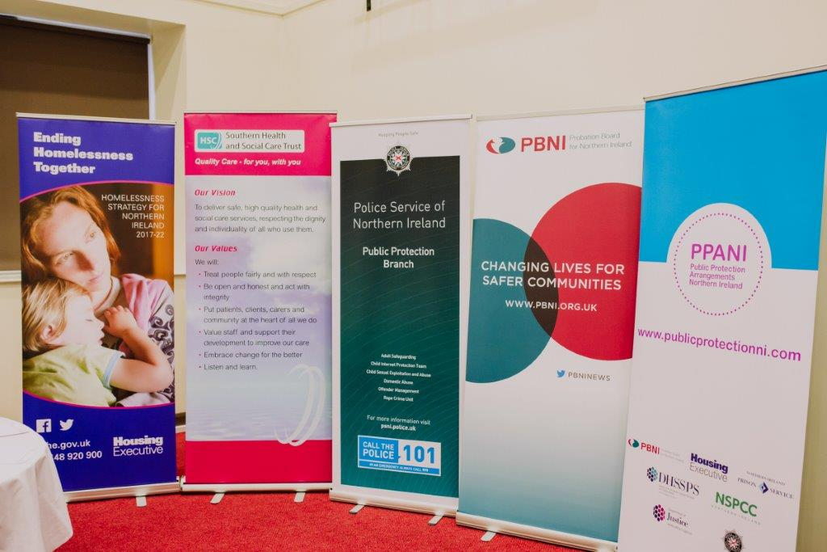

**Strategic Management Board**

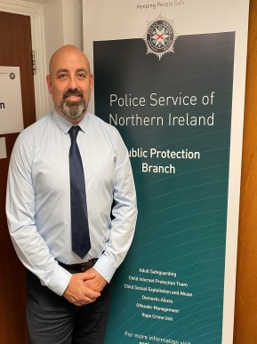 

Superintendent Anthony McNally, PSNI Alan Smyth, NIPS

 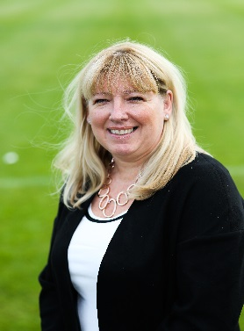

Hugh Hamill Bronagh Muldoon

Probation Board Northern Ireland NSPCC in Northern Ireland

 

Mark Ingham Paul Morgan

Northern Ireland Housing Executive Southern Health and Social Care Trust



Martin Quinn, Health and Social Care Board

**Lay Advisors**



Jonathan Patton

Lay Advisors are appointed by the Minister for Justice, under the Criminal Justice Northern Ireland Order 2008, to ensure there is openness, transparency and public representation alongside the Statutory Agencies with responsibility for Public Protection. The two members of the public appointed to the post of PPANI Lay Advisor can serve no more than six years to ensure a revitalised and refreshed approach. The role is often referred to as a ‘critical friend’.

As Lay Advisors we are allocated 48 days annually to attend Board Meetings, where strategy and overall governance is set, Committee Subgroups where issues such as accommodation, policy and practice and victims’ issues are reviewed, discussed and developed, Local Area Public Protection Panels, where we observe individual cases being reviewed and Quarterly Case Audits, where we review quality and the attainment of standards. There are also Training Events and Seminars where we can liaise with experts in the field of offender management and other stakeholders in order to keep abreast of current best practice and public thinking. The work we undertake is spread across all of the activities of the Public Protection Arrangements and help ensure that the Arrangements are robust and delivered effectively and equitably. Lay Advisors separate out the duties both thematically and geographically to ensure effective coverage and avoiding duplication of roles and responsibilities.

The ongoing management of offenders is a complex area of work and is one of the primary areas of focus for us when we observe Local Area Public Protection Panels (LAPPPs). By observing LAPPPs across Northern Ireland, we get to see and hear first-hand how the Arrangements are working and most importantly ensure that communication between the Agencies involved is clear, concise and timely and that risk is being assessed with all of the information that is known at that time.

I commenced this new year of serving with the Arrangements as the sole Lay Advisor as my colleague Joe Blake completed his allotted six years’ service as a Lay Advisor. I say thank you to him for his guidance, support and input over that time and for the significant contribution he made to the Arrangements throughout his appointment. Recruitment of a second Lay Advisor had been halted due to the absence of a Department of Justice Minister and NI Executive. Now that it has been reinstated in January 2020 we hope for a speedy resolution to ensure the continued external scrutiny and oversight of the Arrangements.

During the year I have observed a number of LAPPPs across Northern Ireland and continue to be impressed by the contributions and level of diligence by the Agency personnel involved in offender management. It becomes evident very quickly when reading reports and listening to verbal accounts that high-quality work is being completed to protect the public. I want to recognise and praise that quality of delivery, however at LAPPP’s and at Quarterly Audits we do discover work that falls below the standard expected and it is then my responsibility as a Lay Advisor to constructively challenge it and feedback to PPANIs Strategic Management Board on these issues and encourage Agencies to implement the required improvements. In addition, the Quarterly Case Audits provide Lay Advisors the opportunity to work with key Agency personnel in a multi-agency – multi-disciplinary setting where extensive discussion, dialog and learning can take place to further increase our levels of understanding and promote enhanced working practices.

The Public Protection Arrangements for Northern Ireland are a robust and well-developed system designed to assess and manage the risk posed by sexual and certain violent offenders. It is widely recognised that the Northern Ireland Arrangements are amongst the best developed anywhere around the world.

Hence it was with great pleasure that I was able to spend time discussing the role of independent challenge and oversight within the Arrangements with Inspector Mark Goldspink from Victoria Police Offender Management Project. Inspector Goldspink had travelled to Northern Ireland on the Churchill Fellowship to explore our Arrangements and learn from our work before returning to implement public protection safeguards in his home city of Melbourne Australia.

The Annual Special Interest Seminar this year was postponed due to the NOTA (National Organisation for the Treatment of Abusers) International Conference being held in Belfast at the same time of year. I was able to attend and listen to international speakers and experts in their field but equally the voice of victims was heard very clearly with lived experience relayed under the title ‘From Survivor to Thriver’ – undoubtedly one of the most inspirational talks I have ever heard.

Throughout the year I was invited by some of our stakeholders such as Women’s Aid, Belfast Trust Domestic Violence Partnership Victims Support, the Diocese of Down & Connor, the Simon Community Hostel Portadown, NIACRO and NOTA (who held their annual International Conference in Belfast this year) to attend their events which helps promote relationships and develop a deeper understanding for me of our victims and survivors. The information gleaned helps inform my challenge within the Arrangements.

The year was extremely busy and rewarding but as I write this report lockdown is looming and who knows what will unfold as we enter a new year in the Public Protection Arrangements.

As the Lay Advisor, I would wish to commend all who work within the Arrangements for the exceptional work they do and the times they go above and beyond to deliver an excellent service in safeguarding our Communities.



**Key Achievements 2019-20**

Over the past year, the PPANI agencies have continued to work together and share information to inform and provide robust risk management plans for PPANI eligible offenders (sexual and certain violent offenders). There have been a number of developments in the past 12 months which have enhanced the effectiveness of the arrangements and helped the agencies work better to protect the public:

* Continued to engage with MLAs and PCSPs
* Held a well-attended and received lunchtime seminar on elder abuse
* Continued to build upon relationships with SORAM colleagues in ROI re training and partnership working
* Continue to review the PPANI Manual of Practice
* Revised the PPANI Offender and Victim Booklets
* Hosted a visit from Senior Sergeant, Victoria Police re Offender Management
* Met with colleagues across other jurisdictions
* In place of the annual Special Interest Seminar, PPANI linked with the NOTA International Conference hosted in Belfast between the 18th-20th September 2019. During this event:
  + SMB Chair contributed to discussion panel re Policing
* Agency reps from PBNI, PSNI and Social Services, alongside the PPANI Coordinator delivered two workshops ‘A Tale of Two Cities’ or ‘not in my Backyard’: the Challenge of Meeting the Housing Needs of Individual Sex Offenders in Northern Ireland & the Republic of Ireland’ & ‘The Co-located Public Protection Team: the challenges for a multi-agency co-located team in managing the risks posed by individuals convicted of sexual and violent offences and assessed as the highest Category of risk under the Public Protection Arrangements N Ireland’.
  + Workshop on accommodation was run in partnership with SORAM colleagues.

**Our Objectives for the next 12 Months**

The Strategic Management Board have a number of key objectives for the coming 12 months. These include:

* Ensuring the implementation and recommendations of Serious Case Reviews.
* Ongoing engagement with community groups, the media and elected representatives.
* Completion of Review of the current Manual of Practice
* Relaunch of the Child Protection Disclosure Arrangements
* Redevelopment and Relaunch of Stop It Now NI
* Implementation of findings and recommendations from the 2018/19 CJINI Inspection of PPANI
* Progress Circles of Support and Accountability

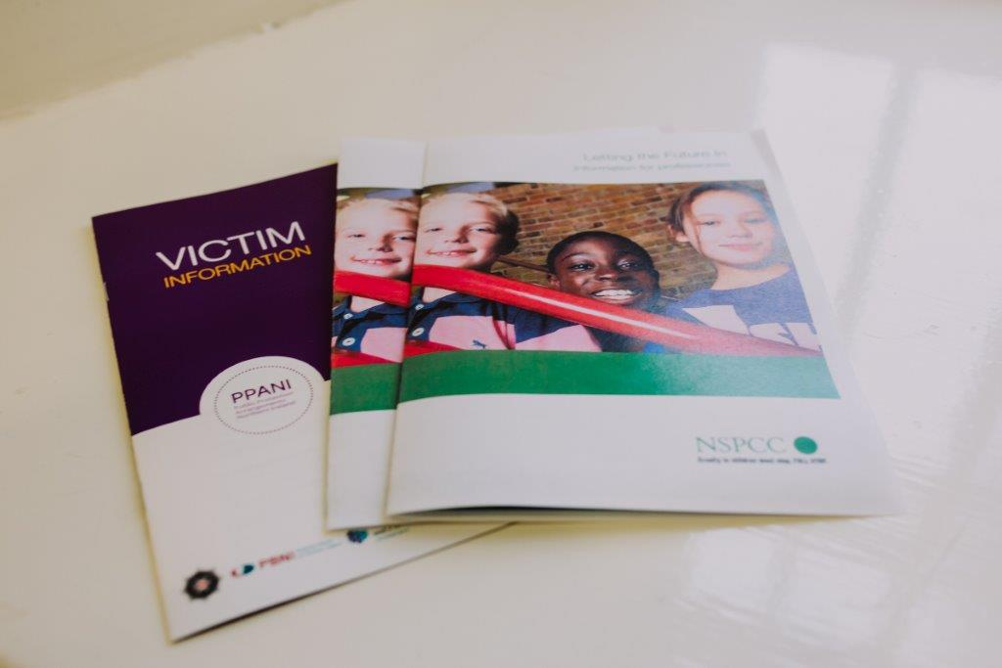

**PPANI Statistics**

|  |  |
| --- | --- |
| Number of Cat 2 offenders at 31st March 2020 | 205 |
| Number of Cat 3 offenders at 31st March 2020 | 25 |
| Total Cat 2 and 3 Offenders at 31st March 2020 | 230 |

|  |  |
| --- | --- |
| LAPPP data 1st April 2019 - 31st March 2020 | |
| Total number of LAPPP Reviews | 715 |
| Number reviewed in community | 568 |
| Number reviewed in custody | 147 |
| Number of Initial Referrals | 303 |
| Number of Review Referrals | 373 |
| Number of Re-referrals due to Significant Concerns | 41 |
| Number of Cases re-categorised to Cat 1 | 262 |

|  |  |
| --- | --- |
| DRM by Agency At 31st March 2020 | |
| PBNI | 249 |
| PSNI | 269 |
| NIPS | 80 |
| Social Services | 0 |
| Trusts | 2 |

**Explanatory commentary on statistical tables**

a) The totals of PPANI eligible offenders, broken down by category, reflect the picture on 31st March 2020 (i.e. they are a snapshot).

b) Sex offenders – those who are required by law to notify the police of their name, address and other personal details and to notify any changes subsequently (known as ‘notification requirements’ or ‘the sex offender register’). Failure to comply with the notification requirements is a criminal offence which carries a maximum penalty of 5 years imprisonment.

c) Violent offenders – those who have been convicted of a violent offence against a child or vulnerable adult, or violent offences within a domestic situation, as well as other violent offences which have been aggravated by hostility.

d) Public Protection Team (PPT) - This is a small team of highly experienced police, probation and social services staff whose aim is to provide a consistent level of management of risk for those offenders in the community who represent the greatest cause for concern.