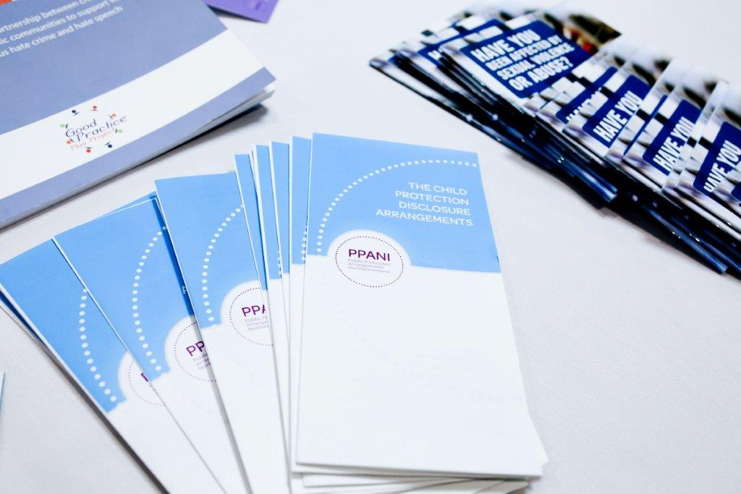

**PPANI ANNUAL REPORT**

**1st April 2018 – 31st March 2019**

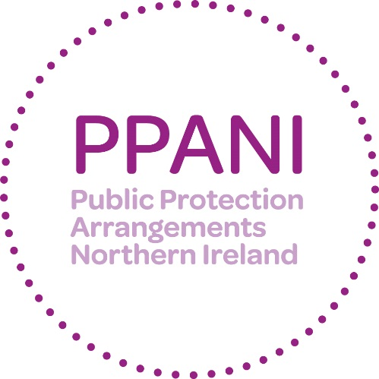

**Forward – Alan Smyth, Chair of Strategic Management Board**

I am pleased to introduce the 2018/19 annual report on the Public Protection Arrangements in Northern Ireland (PPANI).

The purpose of this report is to demonstrate the accountability of PPANI to the public and to provide reassurance that, under the governance of the Strategic Management Board, the arrangements continue to provide an effective framework for managing the risks to the public posed by sexual and certain violent offenders. This report reflects the contributions made by all the agencies involved in PPANI during the last business year and looks back on developments over that period.

Multi-agency working improves information sharing, joint decision making and coordinated intervention. Over the last year there have been a number of developments that have enhanced these elements of our work.

One of the most important aspects of this work is to provide information and raise awareness of public protection issues to the public in order that they can protect and keep safe young people and the most vulnerable in society. The PPANI Coordinator and staff from the agencies have continued to deliver awareness raising presentations and provide information to a range of community/voluntary sector groups (including church & faith groups), local Councils, Policing & Community Safety Partnerships and MLAs.

At the beginning of the reporting period PPANI supported and promoted the launch of the PSNI’s Domestic Violence Abuse Disclosure Scheme. August 2018 saw the publication of a research piece entitled “Profile of Offenders Subject to Public Protection Arrangements NI during September 2016”. This informative work helped us understand more about the particular cohort of offenders we deal with. We then held our Annual Special Interest Seminar for practitioners at Crumlin Road Gaol on Friday 19 October 2018 with the theme “How research influences practice“. This well attended seminar heard presentations on the aforementioned research, on Adverse Childhood Experiences, on the Probation Board’s mobile phone App “*Changing Lives*” and on a new police initiative in England & Wales that uses polygraph testing for sexual and violent offenders. As in previous years the Annual Special Interest Seminar provided practitioners from all PPANI agencies with the opportunity to focus on areas of innovation and share ‘best practice’ regarding this complex and challenging area of work.

Finally during 2018/19 PPANI agencies participated in a thematic inspection of Public Protection Arrangements that was being undertaken by the Criminal Justice Inspection and in several serious case and internal reviews.

The period 2018/2019 was a time of stability in respect of agency representation on PPANI’s Strategic Management Board. I want to take this opportunity to acknowledge each member’s contribution to our work and success.

This reporting period marked my third and final year as Chair of PPANI SMB. I have thoroughly enjoyed the role and the many challenges it brought. I wish my successor, Chief Superintendent Paula Hilman MBE, every success as she takes over the role.

In closing I would like to thank our staff from across all the PPANI partner agencies for their commitment and dedication to this particularly challenging and complex area of work.

**Alan Smyth**

**WHAT IS PPANI?**

# PPANI background

The Criminal Justice Order (NI) 2008 created the public protection arrangements. The arrangements bring together a number of agencies and departments including the police, probation, prison service, health trusts and a number of other agencies to work together to provide effective assessment and management of the risks posed by certain sexual and violent offenders.

# List of agencies and Departments statutorily obliged to cooperate under PPANI

* Police Service of Northern Ireland
* Probation Board for Northern Ireland
* Northern Ireland Prison Service
* HSS Boards and HSS Trusts (Social Services)
* Northern Ireland Housing Executive
* Department of Education
* Department for the Economy
* Department of Health
* Department for Communities
* Education and Library Boards
* Youth Justice Agency
* National Society for the Prevention of Cruelty to Children (NSPCC)
* Health & Social Care Board
* Health Trusts

The arrangements in Northern Ireland also have two Lay Advisors; they are full members of the Strategic Management Board and their role is to provide a challenge to the professionals and act as a “critical friend”. The Department of Justice has policy responsibility for the risk assessment and management arrangements set out in the Criminal Justice (NI) Order 2008. The DoJ also acts to ensure that the funding provided is allocated to effectively deliver oversight of arrangements; and to ensure that all appropriate information regarding the public protection arrangements is provided to the Minister.

# How PPANI works

The agencies listed above work together, within the Public Protection Arrangements, to decide how best to minimise the likelihood of offenders further causing serious harm to the public.

Offenders including those convicted of certain Sexual Offences, Violent Offences, Hate Crimes and Domestic Violence are identified and information about those offence types is gathered and shared across relevant agencies. The nature and level of the risk of harm they pose is assessed and, where necessary, a risk management plan is implemented to protect the public. In most cases, the offender will be managed under the single agency statutory responsibilities of the relevant responsible agencies. However, a number of offenders will require multi-agency assessment and their risk management plans will be developed and actioned via multi agency Local Area Public Protection Panels (LAPPPs). These panels are made up of representatives from the agencies that have a statutory responsibility or operational interest in the cases which are subject to assessment and management of risk. LAPPPs meet in various locations throughout Northern Ireland. For a full explanation on the operations of PPANI visit our website <http://www.publicprotectionni.com/index.php/operation>

# Risk assessment

Information relating to risk is presented to the Local Area Public Protection Panel (LAPPP) for assessment. The LAPPP is chaired by a Probation Board Area Manager and made up of Police Officers, Probation Officers, Social Workers, Prison Staff and other professionals.

This assessment process results in the offender being confirmed in one of three categories of risk:

### Category 1

Someone whose previous offending and/or current behaviour and/or current circumstances present little evidence that they could cause serious harm through carrying out a contact sexual or violent offence.

### Category 2

Someone whose previous offending and/or current behaviour and/or current circumstances present clear and identifiable evidence that they could cause serious harm through carrying out a contact sexual or violent offence.

### Category 3

Someone whose previous offending and/or current behaviour and/or current circumstances present clear and identifiable evidence that they are highly likely to cause serious harm through carrying out a contact sexual or violent offence.

# Information that can be shared about offenders

The Public Protection Arrangements aim to ensure that relevant information is available in good time to help those making risk assessments and drawing up risk management plans. The agencies involved recognise that the sharing of information between agencies is critical and each has signed up to an information sharing agreement. The current law on data protection prevents complete disclosure of information on offenders to the public. Information can, however, be disclosed to members of the public in certain circumstances where this is deemed necessary for protecting the public and can be justified by the evidence of risk.

# Risk Management

For cases where the risk level is assessed as Category 1, these are managed by a single agency in the community.

Multi-agency risk management plans are developed where the risk is assessed as Category 2 and Category 3. For each of the categories, a Designated Risk Manager (DRM) will be appointed. The DRM will be given specific responsibility for coordinating the risk management plan and ensuring that the actions contained in it are carried out. Risk management plans are specifically tailored to each offender and set out all the actions which the agencies will take, or require the offender to take, to minimise the risks he or she poses. Risk management plans will normally include both enforcement actions to restrict the offender’s behaviour and positive encouragement actions designed to help him or her avoid causing serious harm through reoffending.

Each risk management plan will include home visits from the DRM, and other professionals including police to make sure the offender is complying with the plan.

Visits will be both announced and unannounced. Risk management plans for Category 2 and 3 are subject to reviews by the Local Area Public Protection Panels no later than every 16 weeks.

# Ensuring a Victims Perspective

The importance of protecting victims of crime and properly addressing their needs is fully recognised and supported by those agencies operating within the arrangements. When planning for the management of offenders in the community, the protection of victims remains of paramount importance. Victims of offenders whose risks are being managed by agencies within the public protection arrangements are provided with an information pack relevant to their own particular circumstances. They will also be provided with the name and telephone number of a police officer who will act as a point of contact on the Public Protection Arrangements.

There are also a number of schemes/organisations that can provide assistance and information. In 2012 the Prisoner Release Victim Information Scheme, the Probation Board for Northern Ireland Victim Information Scheme and the Mentally Disordered Victim Information Scheme were brought together to help streamline services to victims and are managed under the PBNI Victim Information Unit. These schemes are voluntary and it is necessary to register with them. Information can be obtained regarding the PBNI Victim Information Scheme via [victiminfo@pbni.gsi.gov.uk](mailto:victim@pbni.gsi.gov.uk). Information regarding the Prisoner Release Victim Information Scheme can be obtained via [NIPRVIS@dojni.x.gov.uk](mailto:NIPRVIS@dojni.x.gov.uk).

At an operational level victims’ issues are also central. At each Local Area Public Protection Panel (LAPPP) meeting, victims’ issues are standing agenda items.

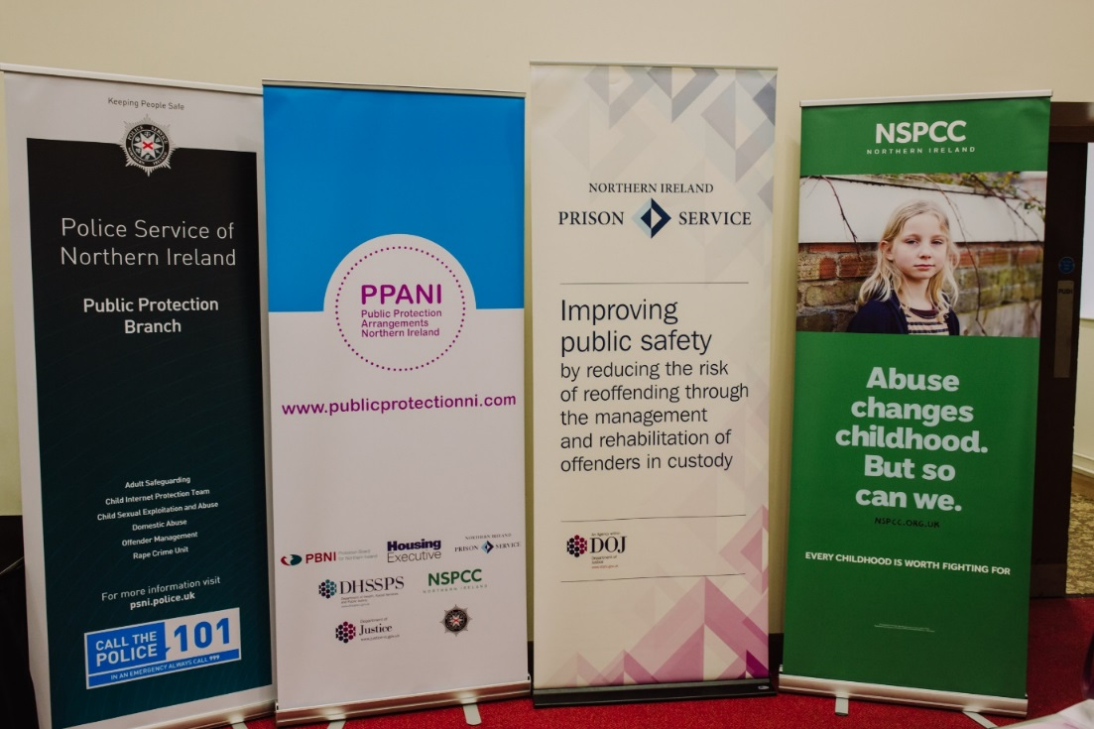

**Strategic Management Board**

 

Alan Smyth, NIPS, SMB Chair Chief Superintendent Paula Hilman, PSNI

 

Hugh Hamill Bronagh Muldoon

Probation Board Northern Ireland NSPCC in Northern Ireland

 

Mark Ingham Paul Morgan

Northern Ireland Housing Executive Southern Health and Social care Trust

**Lay Advisors**

 

Jonathan Patton Joe Blake

Lay Advisors are appointed by the Minister for Justice, under the Criminal Justice Northern Ireland Order 2008, to ensure there is openness, transparency and public representation alongside the Statutory Agencies with responsibility for Public Protection. The two members of the public appointed to the post of PPANI Lay Advisor can serve no more than six years to ensure a revitalised and refreshed approach. The role is often referred to as a ‘critical friend’.

As Lay Advisors we are allocated a total of 48 days annually to attend Board Meetings, where strategy and overall governance is set, Committee Sub Groups where issues such as accommodation, policy and practice and victims issues are reviewed, discussed and developed, Local Area Public Protection Panels, where we observe individual cases being reviewed and Quarterly Case Audits, where we review quality and the attainment of agreed standards. There are also Training Events and Seminars where we can liaise with experts in the field of offender management and other stakeholders in order to keep abreast of current best practice and public thinking. The work we undertake is spread across all of the activities of the Public Protection Arrangements and help ensure that the Arrangements are robust and delivered effectively and equitably. Lay Advisors separate out the duties both thematically and geographically to ensure effective coverage and avoiding duplication of roles and responsibilities.

The ongoing management of offenders is a complex area of work and is one of the primary areas of focus for us when we observe Local Area Public Protection Panels (LAPPPs). By observing LAPPPs across Northern Ireland, we get to see and hear first-hand how the Arrangements are working and most importantly ensure that communication between the Agencies involved is clear, concise, timely and that risk is being assessed with all of the information that is available at that time.

During the year we have observed a number of LAPPPs across Northern Ireland and continue to be impressed by the contributions and level of diligence by the Agency personnel involved in offender management. It becomes evident very quickly when reading reports and listening to verbal accounts that high-quality work is being completed to protect the public. We want to recognise and praise that quality of delivery, however at LAPPP’s and at Quarterly Audits we do discover work that falls below the standard expected and it is then our responsibility as Lay Advisors to constructively challenge it and feedback to PPANIs Strategic Management Board on these issues and encourage Agencies to implement the required improvements. In addition, the Quarterly Audits provide Lay Advisors the opportunity to work with key Agency personnel in a multi-agency – multi disciplinary setting where extensive discussion, dialog and learning can take place to further increase our levels of understanding and promote enhanced working practices.

of understanding and promote enhanced working practices.

During the year we were able to provide input to Designated Risk Manager training for new incumbents to the role across the three Criminal Justice Agencies. This allowed for the explanation of the Lay Advisor role and build relationships with future practitioners.

As the Board Members representing the public within the Arrangements, we welcomed the opportunity to engage in a public forum held by Newry and Mourne District Council. Their Neighbourhood Watch Coordinators were able to hear about the Public Protection Arrangements to give reassurance and illustrate the work that goes into managing the risk presented by offenders in the community.

Training opportunities during the year was primarily via the NOTA Conference attendance looking at offending patterns and responses in Scotland and Australia as well as well as meeting and discussing with public protection professionals from Gibraltar who were seeking to improve their Arrangements.

As Lay Advisors we engaged fully with the Criminal Justice Inspectorate staff as they sought to audit as an external independent source, the workings and effectiveness of the Arrangements. The engagement was by way of private interviews where we could talk freely about our experience and evidence of the delivery of the Arrangements by the Statutory Partner Agencies.

As our year comes to an end our Chair, Alan Smyth, will complete his tenure of three years at the head of the Strategic Management Board. We thank him for his input, support and leadership throughout his time with the Board. He will continue to represent Prison Service on the Board which will provide important continuity.

The Public Protection Arrangements for Northern Ireland are a robust and well-developed system designed to assess and manage the risk posed by sexual and certain violent offenders. It is widely recognised that the Northern Ireland Arrangements are amongst the best developed anywhere around the world. However, as with many other government bodies and agencies, agencies contributing to the Arrangements depend on funding commensurate with the level of service expected of them and leadership provided by a Minister heading up the Department of Justice. The continued absence of a Justice Minister means that major decisions and long term planning is absent and it would be negligent of us as Lay Advisors, appointed by the Minister, not to highlight that the continued and now long-term lack of a Minister and Government in NI has the potential to have a negative impact on the Arrangements in NI and increase the risk of not being able to deliver the Arrangements to level expected by us all.

As Lay Advisors, we would wish to commend all who work within the Arrangements for the exceptional work they do and the times they go above and beyond to deliver an excellent service to our Communities.

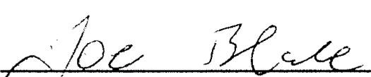 

**Key Achievements 2018-19**

Over the past year, the PPANI agencies have continued to work together and share information to inform and provide robust risk management plans for PPANI eligible offenders (sexual and certain violent offenders). There have been a number of developments in the past 12 months which have enhanced the effectiveness of the arrangements and helped the agencies work better to protect the public.

Among these are:

* Contribute to the implementation of the Domestic Violence & Abuse Disclosure Scheme launched on 26th March 2018
* Publication in August 2018 of research study ‘Profile of Offenders Subject to the Public Protection Arrangements Northern Ireland during September 2016’, completed by Laura Duncan, Analytical Services Group.
* In October 2018, an annual Special Interest Seminar was held for practitioners on the subject of ‘Using Research to Develop Practice’. The Seminar aimed to provide delegates with;
  + A summary of the findings from research completed by Laura Duncan, Analytical Services Group re Offenders subject to the Public Protection Arrangements Northern Ireland
  + An understanding of how ‘Adverse Childhood Experiences’ (ACE’s) can impact upon the lives of individuals and the relevance this has to the management of offenders within the Public Protection Arrangements Northern Ireland
  + An introduction to the Probation Board for Northern Ireland’s Mobile Phone ‘app’ - ‘Changing Lives’ – which aims to help those under supervision to desist from crime.
  + An awareness of a new Police initiative in England & Wales re use of Polygraph Testing with Sexual/Violent Offenders
* PPANI agencies have continued to implement recommendations arising from Serious Case Reviews/Internal Reviews.
* 2018/2019 Participation in a thematic inspection of the Public Protection Arrangements completed by the Criminal Justice Inspection.

**Our Objectives for the next 12 months**

The Strategic Management Board has a number of key objectives for the coming 12 months. These include:

* Ensuring the implementation and recommendations of Serious Case Reviews.
* Ongoing engagement with community groups, the media and elected representatives.
* Contribute to the International NOTA Conference; due to be held in Belfast during September 2019 e.g. delivery of workshops ‘A Tale of Two Cities’ or ‘not in my Backyard’: the Challenge of Meeting the Housing Needs of Individual Sex Offenders in Northern Ireland & the Republic of Ireland’ & ‘The Co-located Public Protection Team: the challenges for a multi-agency co-located team in managing the risks posed by individuals convicted of sexual and violent offences and assessed as the highest Category of risk under the Public Protection Arrangements N Ireland’.
* Completion of Review of the current PPANI Manual of Practice.
* Implementation/consideration of findings and recommendations from the 2018/2019 Criminal Justice Inspection of PPANI.
* Consideration of findings of PPANI effectiveness research.



**PPANI Statistics**

|  |  |
| --- | --- |
| Number of Cat 2 offenders at 31st March 2019 | 151 |
| Number of Cat 3 offenders at 31st March 2019 | 32 |
| Total Cat 2 and 3 Offenders at 31st March 2019 | 183 |

|  |  |
| --- | --- |
| LAPPP data 1st April 2018 - 31st March 2019 | |
| Total number of LAPPP Reviews | 440 |
| Number reviewed in community | 339 |
| Number reviewed in custody | 101 |
| Number of Initial Referrals | 166 |
| Number of Review Referrals | 274 |
| Number of Re-referrals due to Significant Concerns | 13 |
| Number of Cases re-categorised to Cat 1 | 37 |

|  |  |
| --- | --- |
| DRM by Agency At 31st March 2019 | |
| PBNI | 200 |
| PSNI | 188 |
| NIPS | 52 |
| Social Services | 0 |
| Trusts | 0 |

**Explanatory commentary on statistical tables**

a) The totals of PPANI eligible offenders, broken down by category, reflect the picture on 31st March 2019 (i.e. they are a snapshot).

b) Sex offenders – those who are required by law to notify the police of their name, address and other personal details and to notify any changes subsequently (known as ‘notification requirements’ or ‘the sex offender register’). Failure to comply with the notification requirements is a criminal offence which carries a maximum penalty of 5 years imprisonment.

c) Violent offenders – those who have been convicted of a violent offence against a child or vulnerable adult, or violent offences within a domestic situation, as well as other violent offences which have been aggravated by hostility.

d) Public Protection Team (PPT) - This is a small team of highly experienced police, probation and social services staff whose aim is to provide a consistent level of management of risk for those offenders in the community who represent the greatest cause for concern.